Problem Statement

To set up a resourceful website for promoting awareness and conservation of India’s diverse and rich wildlife. It will be a hub for organizing local meetings, wildlife forums, periodicals and wildlife camps.

Project Objectives

* To monitor statistics related to endangered species, jeopardized habitats, unbalanced ecosystems and unfavorable climate changes.
* Secure registration and profile management facilities with registered members, government and NGOs.
* To facilitate members to form groups to organize local meetings, wildlife forums, periodicals and wildlife camps.
* Allow registered members to post relevant photos, videos and other data.
* Regular updates and news flashes about recent events in the field.
* Make the people aware about the importance of conservation of wildlife.
* Attract users towards opportunities and job prospects in the field of wildlife through lucrative advertisements and campaigns.

Feasibility Study

There are very few sites that promote the conservation of Indian Wildlife. Most of them are non-functional. The website will be an all in one package that will focus on promoting conservation to monitoring stats to organizing events. Website will be highly customizable and flexible enough to easily deploy. It’ll seek creative ideas from people to promote conservation of India’s wildlife.

Process Model

Indian wildlife website assures services that are context based and present all the time with its users. The services include user and admin login, services like posting photos, videos and presentations on Indian wildlife, discussion forum and group, user feedback /complaint mechanism etc.

“Waterfall Process Model” will be used for this project. The benefit of this process model is that it is simple and easy to use because, in this model, phases are processed and completed one at a time. The phases do not overlap.

* Waterfall Model works for smaller projects where requirements are very well understood.
* Our product definition is stable.
* Technology is understood.
* There are no ambiguous requirements.
* Expertise is available freely.

Deliverables

* Monitoring statistics and suggesting methods to improve
* Registration and account formation
* Forum for discussion
* Organization of events
* Regular updates and news
* Photos, videos and other data

Windows will be the preferred platform. AJAX will be used for registration forms. E-forms, web services and a CMS (Content Management System) will be used. Microsoft Visio will be used for all graph related tasks. Additional frameworks and platforms will be added depending on the requirements.

Project Scheduling

|  |  |  |
| --- | --- | --- |
| Process | Start Date | End Date |
| Software Requirement | 22-01-15 | 28-01-15 |
| Analyzing User Requirement and  Benefits | 29-01-15 | 04-02-15 |
| Software Design | 05-02-15 | 11-02-15 |
| Detailed Design | 12-02-15 | 25-02-15 |
| Coding and Implementation | 26-02-15 | 25-03-15 |
| Testing | 26-03-15 | 01-04-15 |
| Project Demo | 02-04-15 | 08-04-15 |
| Support and Maintenance | 09-04-15 | 15-04-15 |

Gantt Chart

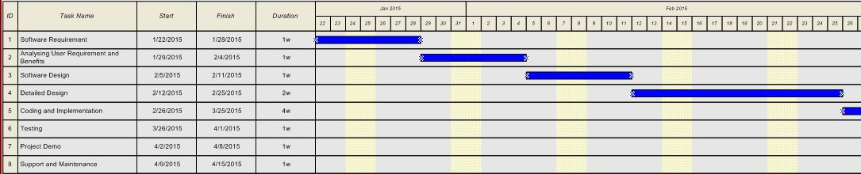

Pert Chart

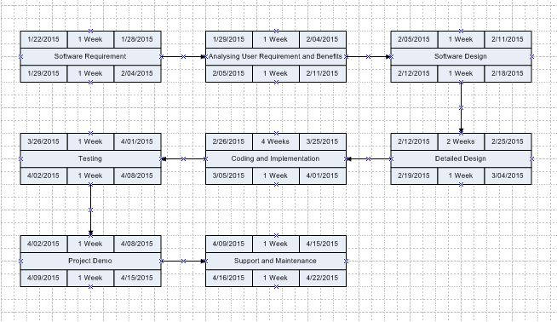

Timeline

